**BUSINESS STUDIES FOR J.S.S.3**

**SCHEME OF WORK FOR THIRD TERM**

|  |  |
| --- | --- |
| **WEEK** | **TOPIC** |
| **1** | **REVISION OF LAST TERM’S WORK** |
| **2** | **ERASING TECHNIQUES** |
| **3** | **MEMORANDUM** |
| **4** | **BUSINESS LETTER** |
| **5** | **BUSINESS LETTER** |
| **6** | **SIMPLE TABULATION** |
| **7** | **REVISION/EXAMINATION** |

**WEEK 2: ERASING TECHNIQUES**

Erase implies a scraping or rubbing out of something written or drawn, or figuratively, the removal of an impression.

Mistakes happen all the time. And that's OK. Everyone makes mistakes. The important thing is to learn from them and erase them as soon as possible once you spot them

**ERASING USING RUBBER**

Before rubber erasers, tablets of wax were used to erase lead or charcoal marks from paper. Bits of rough stone such as sandstone or pumice were used to remove small errors from parchment or papyrus documents written in ink.

**ERASER**

**ERASING USING CORRECTION FLUID**

A correction fluid or white-out is an opaque, usually white fluid applied to paper to mask errors in text. Once dried, it can be written over. It is typically packaged in small bottles, and the lid has an attached brush (or a triangular piece of foam) which dips into the bottle.

**CORRECTION FLUID**

**ASSIGNMENT**

Write short note on the following (a) erasing using correction fluid

(b) erasing using rubber

**WEEK 3: MEMORANDUM**

A memorandum is a written [report](https://www.collinsdictionary.com/dictionary/english/report) that is [prepared](https://www.collinsdictionary.com/dictionary/english/prepare) for a person or [committee](https://www.collinsdictionary.com/dictionary/english/committee) in order to provide them with [information](https://www.collinsdictionary.com/dictionary/english/information) about a particular [matter](https://www.collinsdictionary.com/dictionary/english/matter).

A memorandum can also be regarded as a short [official](https://www.collinsdictionary.com/dictionary/english/official) note that is [sent](https://www.collinsdictionary.com/dictionary/english/send) by one person to another within the same [company](https://www.collinsdictionary.com/dictionary/english/company) or [organization](https://www.collinsdictionary.com/dictionary/english/organization).

**PURPOSE OF MEMORANDUM**

The primary purpose of a memorandum is to support decision making – to “help (or sometimes influence) a decision-maker to make a better decision in a particular problem situation than he might otherwise have made without the analysis”. Other purposes that the briefing note can serve include: conveying information; informing decisions, making a request, providing a response to a question, making a suggestion, presenting an informal report, proposing a solution to a problem, or documenting a reference for future use.

**Structure of memorandum**

As the communication mechanism of the policy analysis process, the memorandum should provide a coherent synopsis of a policy problem, identify different policy options for addressing the problem, articulate opposing perspectives and advocate a recommended option. The typical structure for a memorandum includes: a description of the proposed policy; relevant background information; a discussion of key considerations (including implementation concerns, financial considerations, stakeholder impacts, and possible unanticipated consequences), a summary of arguments for and against the policy and a recommended decision. Policy documents that start with a proposal and assemble an argument that position are more accurately referred to as a government [white paper](https://en.wikipedia.org/wiki/White_paper). A government [green paper](https://en.wikipedia.org/wiki/Green_paper) which raises a policy option and is meant to open a dialogue on the proposal is more similar in tone to a briefing note than is a [white paper](https://en.wikipedia.org/wiki/White_paper).

**TIPS TO WRITING A MEMORANDUM**

• You should write memorandum letters in a brief and simple way. Be direct with the information you are sharing. Memos do not usually exceed a paragraph or two and is usually just bulleted list of information.

• If it is a formal memo that is issued, the first part of the paragraph should state the purpose of the memorandum and then proceed to enlist additional information.

• Maintain a professional tone and use easy-to-understand language in writing the memorandum, it is meant to be read by a number of people. Keep in mind that you should not include any personal statements.

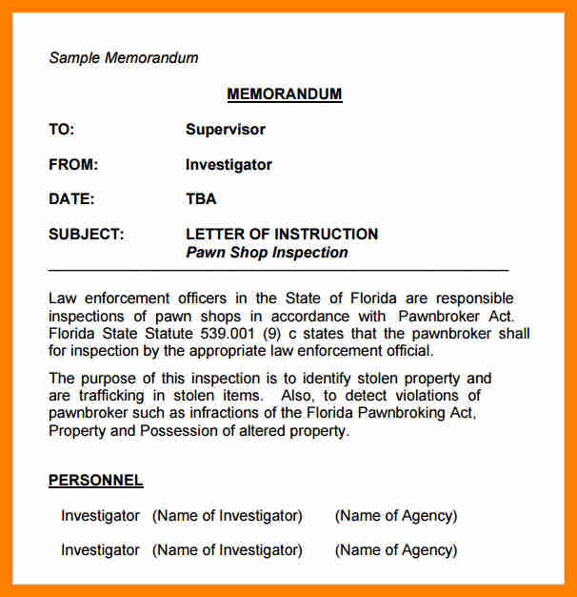 **EXAMPLE OF A MEMORANDUM**

**ASSIGNMENT**

1. Define memorandum
2. Outline 3 tips of writing a memorandum
3. Explain 2 purposes of memorandum

**WEEK 4: BUSINESS LETTER**

**MEANING:** A business letter is usually a letter from one company to another, or between such organizations and their customers, clients and other external parties. The overall style of letter depends on the relationship between the parties concerned.

[**FORMAT FOR WRITING A BUSINESS LETTER**](https://www.thebalance.com/sample-letter-format-2063479)  
A business letter includes:

contact information,

a salutation,

the body of the letter,

a complimentary close, and

a signature.

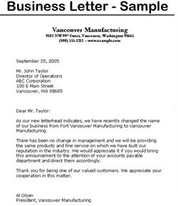

**ASSIGNMENT**

1. Define business letter
2. Write a complaint letter to the manufacturer of the faulty refrigerator you bought on the 24th of March, 2018.

**WEEK 5: BUSINESS LETTER (CONTINUATION)**

**TYPES OF BUSINESS LETTER**

[**Apology Letters**](https://www.thebalance.com/when-and-how-to-apologize-at-work-2062679)  
[When and how to apologize](https://www.thebalance.com/when-and-how-to-apologize-at-work-2062679) at work, plus examples of apology letters for employers and co-workers. Use these letters when you have [made a mistake](https://www.thebalance.com/when-and-how-to-apologize-at-work-2062679), [behaved poorly](https://www.thebalance.com/when-and-how-to-apologize-at-work-2062679), [missed an interview](https://www.thebalance.com/missing-job-interview-email-2059533), or in other circumstances where you've messed up and need to apologize.

[**Appreciation Letters**](https://www.thebalance.com/thank-you-letters-samples-for-the-workplace-1919272)  
Very often, feedback at work is dominated by the negative. If someone you work with closely does a great job, don't miss the opportunity to give praise and positive feedback. Sending a letter is a nice way to let employees, co-workers, colleagues, clients, and others know how much you appreciate them.

[**Business Thank You Letters**](https://www.thebalance.com/how-to-write-an-interview-thank-you-letter-2063981)  
If someone does you a favor or helps you out in any way, always remember to send a thank you note. Browse this link for business thank you letter samples for a variety of business- and employment-related scenarios.

[**Candidate Rejection Letter**](https://www.thebalance.com/candidate-rejection-letter-and-email-examples-2063003)  
When you are in charge of hiring, you will need to inform job applicants when they do not receive the position. Here is an example of a candidate rejection letter to send to an individual who was not selected for a job.

[**Congratulation Letters**](https://www.thebalance.com/congratulation-note-and-email-examples-2060076)  
Everybody loves to be recognized for their achievements, even if it's just a quick email message or a handwritten note.

Review sample congratulation letters for [new jobs](https://www.thebalance.com/congratulations-email-message-example-for-a-new-job-2060080), [new businesses](https://www.thebalance.com/congratulations-email-message-for-a-new-business-2060081), [promotions](https://www.thebalance.com/congratulations-email-message-for-a-promotion-2060082), and other business-related endeavors.

[**Email Message Examples**](https://www.thebalance.com/employment-related-email-message-examples-2061898)  
While it's often nice to send a handwritten or printed out note in the mail, it's more common these days to email. Here you’ll find business- and employment-related email message examples.

[**Employee Letters**](https://www.thebalance.com/employee-letters-4073102)  
Review sample employee letters and letters for job applicants for employment including employee reference letters, job offer letters, appreciation and congratulation letters, and more letter examples.

[**Employment Verification Letter**](https://www.thebalance.com/employment-verification-letter-example-2059489)  
Employment verification letters are often requested by landlords to confirm that a person is employed at a company. See information on what should be included in the letter and a sample employment verification letter.

[**Farewell Letters**](https://www.thebalance.com/farewell-letter-samples-2060863)  
Farewell message examples to let colleagues, clients, and your connections know that you are moving on.

Sending a farewell letter is a good way to update people with new contact information so you can keep in touch in the future.

[**Inquiry Letters**](https://www.thebalance.com/letter-of-interest-tips-and-samples-2059708)  
Use inquiry letters to request meetings and to inquire about job opportunities that haven't been advertised. These letters are a way to get your foot in the door at a prospective employer who hasn't publicly listed available jobs.

[**Job Offer Letters**](https://www.thebalance.com/job-offer-letter-samples-2061694)  
Examples of job offer letters, a [job rejection letter](https://www.thebalance.com/how-to-decline-a-job-offer-2059772), counter offer letters, and more letters related to offers of employment.

[**Job Promotion Letter**](https://www.thebalance.com/job-promotion-letter-example-2061683)  
A job promotion letter gives information on the promotion, including the employee's new title, salary, and the date the employee is transitioning into the new role.

[**Networking Letters**](https://www.thebalance.com/types-of-networking-letter-examples-2063489)  
Sample job search and career networking letters including [referral letters](https://www.thebalance.com/referral-cover-letter-example-2063484), [letters of introduction](https://www.thebalance.com/letter-of-introduction-examples-and-writing-tips-2062593), and [networking](https://www.thebalance.com/types-of-networking-letter-examples-2063489) outreach letters.

[**New Employee Letter**](https://www.thebalance.com/new-employee-welcome-aboard-letter-example-2064229)  
Sample welcome letter to send to a new employee, as well as details on the information to include in this type of letter.

[**Promotion Announcement**](https://www.thebalance.com/promotion-announcement-examples-and-writing-tips-2061684)  
Sample email message notifying company employees about a promotion.

[**Reference Letters**](https://www.thebalance.com/reference-letter-samples-2062971)  
See examples of reference letters, recommendation letters, personal references, professional references, character references, and academic references.

[**Referral Letters**](https://www.thebalance.com/referral-letters-4073101)  
Referral letter examples including letters and email messages requesting a referral, letters referring employees, a colleague, or an acquaintance for a job, and examples of referral cover letters and thank you letters.

[**Resignation Letters**](https://www.thebalance.com/best-resignation-letter-examples-2063519)  
If you are planning on quitting a job, review these resignation letter and email examples. They can be used in a variety of situations, including resigning with notice, resigning over email, and resigning effective immediately.

[**Retirement Letters**](https://www.thebalance.com/retirement-letter-example-to-notify-employer-2063065)  
See letter examples for retirement announcements when you're retiring, and congratulation letters and emails for connections who have retired.

[**Termination Letter**](https://www.thebalance.com/sample-termination-letter-1919094)  
Sample termination letter terminating an employee from an organization.

[**Welcome Back Letters**](https://www.thebalance.com/employee-letters-4073102)  
Examples of welcome back letters for new employees and employees returning to work after a leave.

[**Microsoft Word Letter Templates**](https://www.thebalance.com/free-microsoft-word-resume-and-letter-templates-2062565)  
When you need to write an employment letter, it can be helpful to start from a template. Microsoft Word templates are available for resumes, cover letters, resignation letters, reference letters, and interview letters.

**ASSIGNMENT**

Explain 5 types of business letter

**WEEK 6: SIMPLE TABULATION**

A table is an arrangement of data in rows and columns, or possibly in a more complex structure. Tables are widely used in communication, research, and data analysis. Tables appear in print media, handwritten notes, computer software, architectural ornamentation, traffic signs, and many other places.

To set up your table, do the following:

* Start a new word document
* From a menu bar, click on **Table**
* From the menu that drops down, click **Insert**
* A sub-menu appears and, from the sub-menu, click **Table**

|  |  |  |  |  |
| --- | --- | --- | --- | --- |
|  |  |  |  |  |
|  |  |  |  |  |
|  |  |  |  |  |

The table above has **5 columns and 3 rows**

**ASSIGNMENT**

Construct a table :

1. 6 columns and 4 rows
2. 10 columns and 4 rows
3. 5 columns and 5 rows